DHN1 — DHN1 Task 1: Network Merger and Implementation Plan

Name: Taylor Wilkerson
Student ID: 011041148
Date: 12/1/2025

- Describe two current network security problems and two current infrastructure problems for each company, based on business requirements given in the scenario.

Upon reviewing the completed risk analysis as well as the listed vulnerabilities each company has, there are a multitude of issues that need to be resolved.

Company A Network Security Vulnerabilities:

Company A is facing several significant security issues related to both network configuration and account security. According to the risk assessment, a wide range of unnecessary ports—specifically ports 21–90 and 3389—are currently open. Many of these ports are known to be insecure and should be closed or only enabled when absolutely necessary. For example, port 3389, used for Remote Desktop Protocol (RDP), allows remote graphical access to systems over the internet and has a long history of being exploited. If RDP is required, it should be tightly controlled and limited to authorized administrative users only. Leaving these ports open greatly expands Company A’s attack surface and gives hackers more opportunities to probe the network, especially if they obtain stolen credentials.

In addition to network issues, Company A’s password practices are also weak. The current policy only requires eight-character passwords and does not enforce regular password expiration. Short passwords are much easier to crack through brute-force attacks if an attacker gains access to password hashes. Furthermore, without a password expiration policy, any leaked or stolen passwords can remain valid for long periods, allowing hackers to reuse old credentials to access systems. It is recommended that Company A implement stronger password controls, including longer, more complex passwords and a 60- to 90-day password expiration policy, alongside stricter firewall rules to close all unnecessary ports

Company A Infrastructure Vulnerabilities:

The risk assessment and network diagram show that Company A uses Meraki MR28 wireless access points to connect its Windows laptops. These devices have documented vulnerabilities, including CVE-2022-33279 (NIST, 2024), which could allow an attacker to run arbitrary code on the device or repeatedly reboot the access point, creating a denial-of-service condition. This makes the wireless infrastructure a potential entry point and disruption target for attackers.
In addition, Company A is still relying on multiple pieces of end-of-life (EOL) hardware, such as the Meraki access points and a Cisco 3750X switch. Once equipment reaches the end of service life, the vendor no longer provides security patches or updates, meaning any newly discovered vulnerabilities remain unaddressed. This significantly increases the organization’s attack surface and leaves outdated devices as attractive targets. It is strongly recommended that all EOL equipment be replaced with currently supported models.
The risk is compounded by the fact that all users have local administrative privileges on their systems. This violates the principle of least privilege, which recommends granting users only the access they need to perform their job functions. With universal admin rights, untrained users can accidentally misconfigure systems or install malicious software, and a malicious insider could deliberately abuse these privileges to damage systems, exfiltrate data, or take down large portions of the network. Reducing user privileges and enforcing least privilege would greatly limit both accidental and intentional harm.

Company B Network Security Problems:

The risk assessment for Company B highlights several serious security issues. First, there is a critical Distributed Ruby vulnerability that creates a high risk of remote code execution. If exploited, an attacker could remotely run arbitrary code on Company B’s systems and potentially gain extensive access to sensitive resources.

Company B’s authentication practices further increase this risk. Their current password policy is weak, and multi-factor authentication (MFA) is not enforced for all users. Without MFA, any stolen or leaked passwords—or even cracked password hashes—could allow an attacker to log in directly to company systems, significantly undermining the organization’s overall security posture.

In addition, the PostgreSQL administration interface is exposed to the internet rather than being restricted behind a firewall. This makes the database reachable from outside the internal network, which is especially dangerous if it stores healthcare or financial data. An external attacker could potentially access or compromise this sensitive information, leading to serious privacy, regulatory, and financial consequences. To reduce these risks, Company B should immediately enforce MFA for all users and harden its database by limiting access to trusted internal networks only.

Company B Infrastructure Vulnerabilities:

Company B Infrastructure Security Issues (Combined & Paraphrased)
Company B is dealing with several serious infrastructure security weaknesses. The risk assessment identifies a critical vulnerability on one of its servers running Apache Tomcat, specifically the Ghostcat vulnerability. This flaw allows attackers to retrieve arbitrary files from web applications on the server and could potentially expose sensitive data or be used as a stepping stone for further compromise (Sethi, 2020).
In addition, Company B relies on multiple end-of-life (EOL) devices, including its current router, older workstations, and outdated operating systems. Because these systems no longer receive security patches or updates from the vendor, any newly discovered vulnerabilities remain unmitigated, making them attractive targets for attackers. Upgrading these systems to supported versions and applying the latest vendor updates is essential to reduce this risk.
The company also lacks redundancy and high availability for its critical medical systems. Without backup servers or clustering in place, a single server failure can lead to downtime, data loss, and major disruptions for medical providers who rely on these applications. Implementing high-availability solutions and robust backup strategies would help ensure continuity of operations and protect against both technical failures and cyber incidents.

B. Analyze the given network diagram and vulnerability scan for both companies by doing the following:
1. Describe two existing vulnerabilities for each company.

2. Explain the impact, risk, and likelihood associated with each described vulnerability from part B1 as it relates to each company.

Existing Vulnerabilities – Company A vs. Company B
Company A
The risk assessment shows that Company A has several serious weaknesses in its current environment. Numerous unnecessary ports are open, including ports 21–90 and port 3389. Port 3389 is used by Remote Desktop Protocol (RDP), which, if exposed, can allow a threat actor to remotely access internal systems. When combined with Company A’s weak password policy—users relying on only eight-character passwords—the risk is amplified. If an attacker obtains or cracks a user’s credentials, they could use RDP to log directly into company systems.
In addition, Company A’s wireless access points are at end of service life. Because these devices no longer receive security updates, they are more attractive targets for attackers. One known issue, CVE-2022-33279, could allow arbitrary code execution on these access points, further increasing the likelihood of compromise (NIST, 2024).
Overall, the impact of these vulnerabilities is significant: unauthorized access to sensitive systems and data, potential lateral movement across the network, and large-scale operational disruption. Given the open ports and weak passwords, the risk is High and the likelihood is High that these vulnerabilities could be exploited.
Company B
Company B’s third-party risk assessment identifies an even broader set of vulnerabilities. One key issue is that all users have local administrative privileges on their machines. If an attacker gains a user’s password, they immediately inherit admin-level rights. With that level of access, a threat actor can establish persistence, hide or alter logs, disable endpoint protections, and move laterally through the environment with ease (Pozhogin, 2023).
Compounding this, Company B does not enforce multi-factor authentication (MFA). Without MFA, a single stolen or phished password is enough to grant full access to a user’s account and potentially the wider network. This dramatically weakens the company’s overall security posture.
From a software and infrastructure perspective, Company B also has critical technical vulnerabilities. There is a Distributed Ruby (dRuby/DRb) remote code execution issue that could allow attackers to gain root-level control of servers or infrastructure devices, posing a severe threat to confidentiality, integrity, and availability (Rapid7, 2023). Additionally, several systems are running end-of-life operating systems that no longer receive security patches, making them highly susceptible to exploitation (Gregg, 2021).
Taken together—local admin rights for all users, lack of MFA, a critical dRuby RCE vulnerability, and end-of-life operating systems—the impact is High and the likelihood of exploitation is High for Company B as well. These conditions create a strong opportunity for attackers to compromise systems, exfiltrate data, and cause significant operational damage.

- Create a network topology diagram with details of the proposed merged network requirements.
The new merged network combines the infrastructures of Company A and Company B with a shared cloud environment. This design is illustrated in two pages of the Microsoft Visio file: Page 1 shows the high-level merged network architecture, while Page 2 zooms in on the physical layouts for both Company A and Company B.
Originally, each company had its own separate setup, including an internet connection, firewall, switches, workstations, and on-premises servers (file and application servers). Company B also maintained a VPN, as shown in an additional diagram.
In the proposed integrated design, these resources are consolidated into a unified environment that includes:
- A single internet connection
- A merged firewall
- Combined switches/routers
- Shared server infrastructure (application servers, file servers, a virtualization layer, and a domain controller)
- Unified workstations across both companies
- Physical locations for Company A and Company B
- A connected cloud environment (Azure AD, cloud storage, and SaaS applications)
- A VPN connection linking the on-premises network to the cloud.
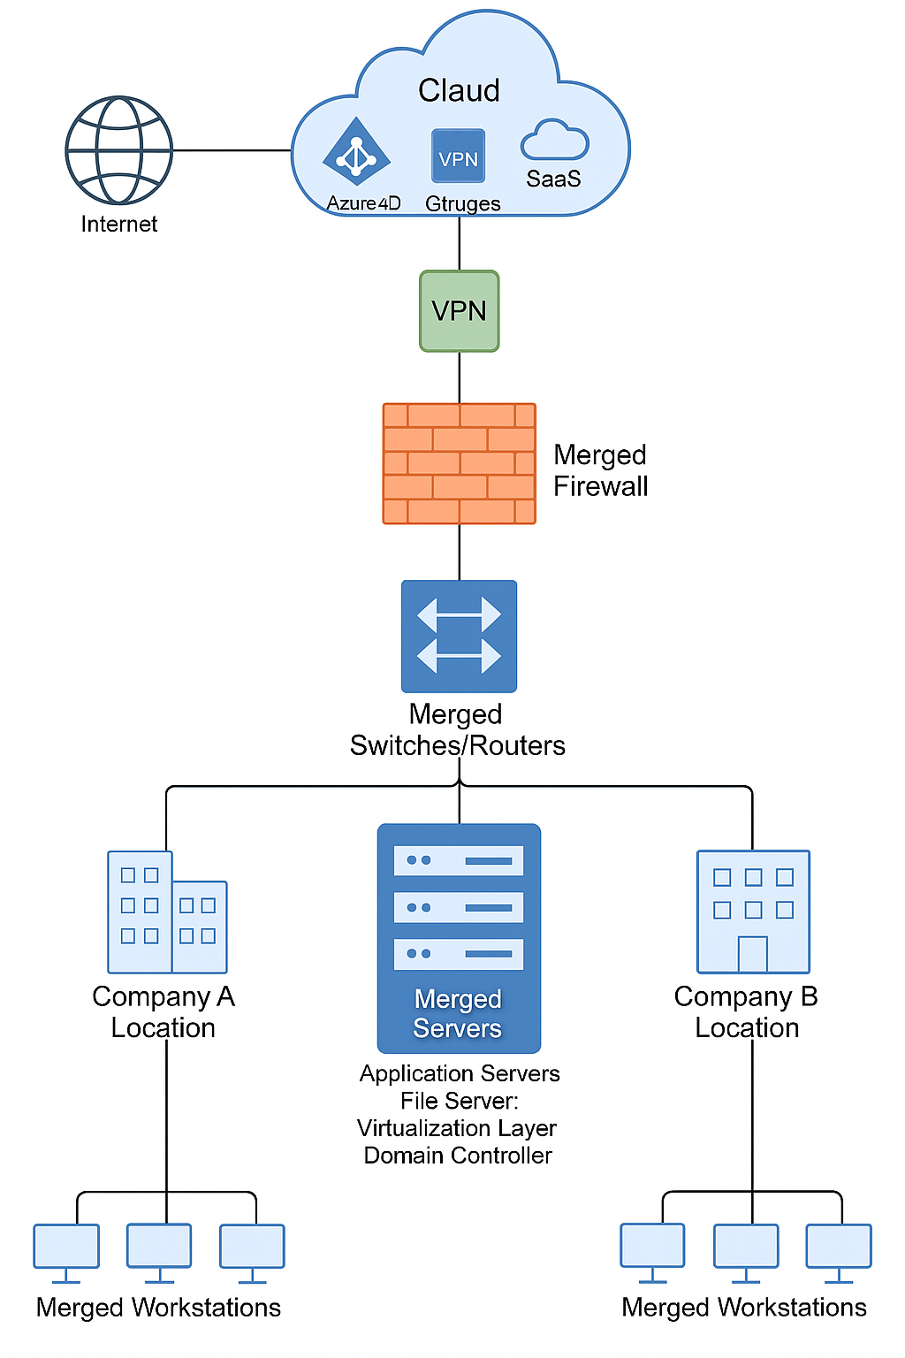

- Identify the layer for all components in the topology diagram referencing the layers of the OSI model and TCP/IP protocol stack.

In the merged topology, switching functions align with OSI Layer 2 / TCP-IP Link, routing and VPN tunneling align with OSI Layer 3 / TCP-IP Internet, and the firewall enforces controls primarily at Layers 3 and 4 with potential Layer 7 inspection in a next-generation configuration. The servers (application, file, domain controller) and cloud services (Azure AD, storage, SaaS) operate mainly at OSI Layer 7 / TCP-IP Application, while endpoints (workstations) function as full-stack hosts that consume services at the application layer. The virtualization layer underpins and enables multiple layers of the stack, with administrative control occurring at the application layer.

- Explain the rationale for adding, deleting, or repurposing network components in the newly merged network topology diagram, including details of how each component addresses budgetary constraints.
The merged topology reflects a security-first but budget-conscious consolidation strategy. Redundant internet edges and firewalls were logically unified to reduce monthly ISP and maintenance costs while centralizing policy enforcement. Switching and routing functions were merged to standardize segmentation and reduce infrastructure sprawl, with selective replacement focused on end-of-life devices rather than full-site overhauls. Server environments were consolidated under a virtualization layer to reduce physical hardware, energy use, and patching complexity, while a centralized domain controller capability supports unified identity governance across both companies. Cloud services such as Azure AD, cloud storage, and SaaS were added to offload aging on-prem dependencies and shift major capital expenditures into predictable subscription models. The VPN capability likely builds upon Company B’s existing implementation to support secure hybrid connectivity without requiring an expensive redesign, enabling phased modernization aligned with short-term budget constraints and long-term scalability.

- Explain two secure network design principles that are used in the proposed network topology diagram.

The proposed merged topology supports Defense in Depth by layering security controls across the perimeter (merged firewall), internal routing/switching (segmentation capabilities), centralized server infrastructure, and secure hybrid cloud access via VPN. It also aligns with the Principle of Least Privilege by emphasizing centralized identity and policy enforcement through the Domain Controller and Azure AD, providing a scalable foundation for role-based access and reduced administrative exposure across both enterprise environments.

G. Explain how the proposed merged network topology diagram addresses two regulatory compliance requirements that are relevant to the newly merged company, including the following in your explanation:
• the name of the regulatory compliance requirement
• why the regulatory requirement is relevant to the newly merged company
• how the proposed merged network topology diagram meets the regulatory requirement

The proposed merged network topology supports compliance with the HIPAA Security Rule by enabling centralized identity and access control through a Domain Controller and Azure AD, improving the organization’s ability to enforce role-based access and consistent authentication for systems that may handle ePHI. The design also incorporates a VPN connection to the cloud to support encryption of sensitive data in transit, and a consolidated firewall boundary to standardize security controls across both locations. These architectural choices align with HIPAA’s technical safeguard requirements for access control, authentication, and transmission security.
The topology also aligns with expectations under the GLBA Safeguards Rule, which applies to organizations that handle consumer financial information and requires appropriate administrative and technical protections. Consolidating edge security into a merged firewall, standardizing core routing/switching, and integrating cloud identity services strengthens the company’s ability to control access and reduce exposure of sensitive financial and identity data as the two environments unify. While policies and formal security programs are still required, the merged architecture provides a cost-efficient structure that supports GLBA-aligned protection of customer information.
H. Describe two emerging threats that are applicable to the merged organization, including the following in the description:
• potential network security risks of implementing the topology
• potential performance impacts on the merged network after implementation of the proposed design
• how to manage the identified potential security risks

Two emerging threats applicable to the merged organization are hybrid identity compromise and ransomware targeting critical operations. The integration of Azure AD with a centralized Domain Controller strengthens governance but also means stolen credentials could grant cross-environment access if MFA and conditional access are not enforced. AI-enhanced phishing and credential-based attacks make this risk particularly urgent, though implementing strong identity controls may introduce minor authentication overhead.
Additionally, ransomware remains a major threat to critical sectors, and the consolidation of servers and networks can expand the blast radius if segmentation and legacy system removal are not prioritized. The merged topology should therefore be supported with strict segmentation, rapid decommissioning of end-of-life systems, and resilient backup/restore capabilities to reduce operational downtime and data loss risk while maintaining acceptable network performance during transition.
I. Summarize your recommendations for implementation of this proposed merged network based on the scenario and budgetary requirements, including the following in the summary:
• a cost-benefit analysis for on-premises and cloud infrastructure solutions
• a justification for your recommendations to implement the proposed secure merged network design

The recommended implementation approach for the proposed merged network is a hybrid model that consolidates and standardizes existing on-prem infrastructure while leveraging cloud services for identity, storage, and SaaS to reduce capital expenditures. On-prem solutions remain valuable for legacy and latency-sensitive functions, especially when consolidated under a virtualization layer that reduces physical server sprawl and operational overhead. Cloud adoption provides faster access to modern security controls and resilience without requiring an immediate full hardware refresh. This design is justified because it directly mitigates the most critical risks identified in both companies—such as open network exposure, weak authentication practices, end-of-life equipment, excessive user privileges, and limited availability—while enabling phased modernization that aligns with budget constraints and minimizes disruption to business operations.

J. Acknowledge sources, using in-text citations and references, for content that is quoted, paraphrased, or summarized.

References

DHN1 — DHN1 Task 1: Network Merger and Implementation Plan. (n.d.). WGU
Coursework.
https://tasks.wgu.edu/student/011041148/course/28940012/task/3898/overview

NIST (2024, May 29) CVE-2022-33279 Detail
NIST (2024, May 29) CVE-2022-33279 Detail
NIST (2024, May 29) CVE-2022-33279 Detail
NIST (2024, May 29) CVE-2022-33279 Detail
NIST (2024, May 29) CVE-2022-33279 Detail
https://nvd.nist.gov/vuln/detail/CVE-2022-33279

Pozhogin, A (2023, Jan 1) Why No User Should Have Local Admin Rights
https://www.cyberark.com/resources/blog/why-no-user-should-have-local-admin-rights

Sethi, T (2020, Mar 31) What is the Ghostcat vulnerability (CVE-2020-1938)?
https://www.synopsys.com/blogs/software-security/ghostcat-vulnerability-cve-2020-1938.html

